Adtran TA5000 Series GPON Programming
(Remote Tech Assist)

Table of Contents

1.0 Overview 3
2.0 Effective Date 3
3.0 Related Documents 3
4.0 Accessing the Adtran 4
4.1 Optius 4
4.2 Poll DSLAM 6
5.0 ONT Discovery 7
6.0 Create New ONT 9
7.0 ONT Activation 11
7.1 DUMY ONT 12
8.0 Base ONT provisioning 19
9.0 Provision the ONT, Ethernet Port 20
10.0 Create Interface Map 22
10.1 Subscriber Interface 25
11.0 Create Shapers 25
11.1 Creating Downstream Shaper 25
11.2 Creating Upstream Shaper 28
12.0 Identify Interface Map 29
13.0 Deleting Interface Map or Shaper 30
14.0 Firmware 31
15.0 Troubleshooting 31
15.1 PON Operational Status/Testing 31
15.2 Searching Unrecognized ONT’s 33
15.3 Using FDT to Verify Assigned Splitters at FDH 34
15.4 Conflict with EVC Map Error 36
15.5 Identifying if ONT Serial Number is Connected to Wrong Splitter 36
16.0 Document Management 38

Overview

Target Audience | Programming
Impact/Benefit | This document provide details for programming Adtran TA5000 Series GPON.  The GPON network consists of an OLT located at the central office (TA5000) and the Optical Network Terminal (ONT) located at the customer’s premises. Between that lies the Optical Distribution Network (ODN) comprised of fibers and passive splitters or couplers. GPON technology is based on Passive Optical Network (PON) technology.  Manual programming should only be performed when Open Switchgate (OSG) through Optius can no longer be leveraged.
Reason for Change | Changed document Author from Joela Flaxa to Debra Rudrud.  Updated the DUMY ONT section to include precursory steps from the separate Adtran – DUMY ONT (QF Tech Assist) document, as that document will be archived.  Added the Identifying if ONT Serial Number is Connected to Wrong Splitter section and archived the separate document Adtran – Identifying if ONT Serial Number is Connected to Wrong Splitter (QF Tech Assist and QF Structure Load).  Removed the link to the Poll Dslam document, per Poll Dslam did not come to FF37.  Added the Firmware section.  Added the Identify Interface Map section.

Effective Date

Effective Date | Expiration Date
04/08/25 | Until Further Notice

Related Documents

Document Name
Visit the library to view all documents: https://centurylink.sharepoint.com/sites/NAOLibrary

Accessing the Adtran
Step | Action
To access the Adtran AOE, see that document.
To access the GUI, open the Windows App, and select a browser.
 | Select a browser.
Populate the IP address for the device as identified in Optius.
This can be found on the order, on the Programming work ticket (see image in Optius section of this document) or on the Ethernet tab, view the OED on the facilities locate the IP address of the CMS server for the OLT to manually program service.

Optius
Step | Action
In Optius navigate to the programming work ticket detail screen to obtain the IP address.
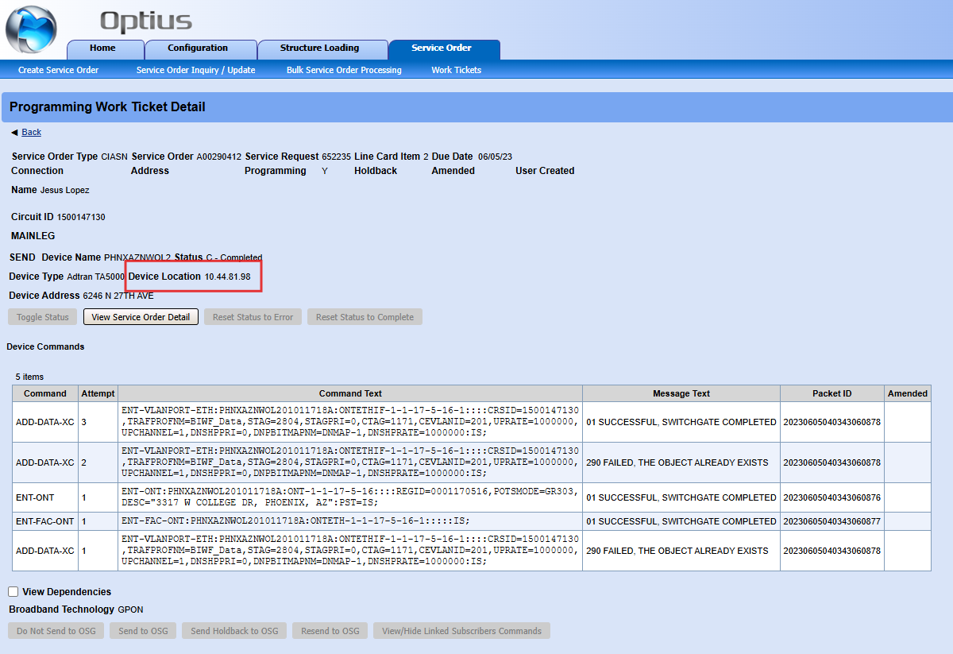
- Open new browser tab and enter IP Address.
- Use Username (CUID) and LDAP Password to log in to Adtran GUI.
- Select Login.
Note: use Chrome or Firefox as the browser.
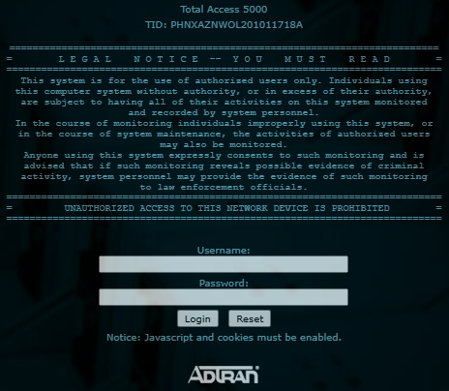
An alternate location to locate the IP Address in Optius would be to use the Service Order Inquiry/Update Inward Details screen.
Note: Mouse over the Entity Attribute * for the OLT to view the IP Address.
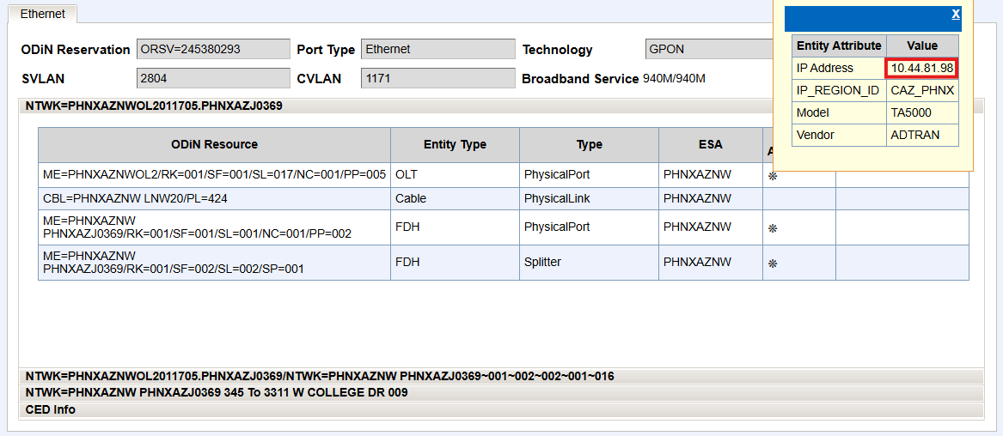

Poll DSLAM
Step | Action
- In Poll DSLAM input DTN
- Select Poll DSLAM
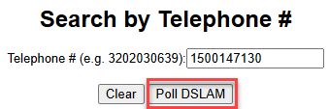
Copy IP Address from DSLAM and Port Information screen.
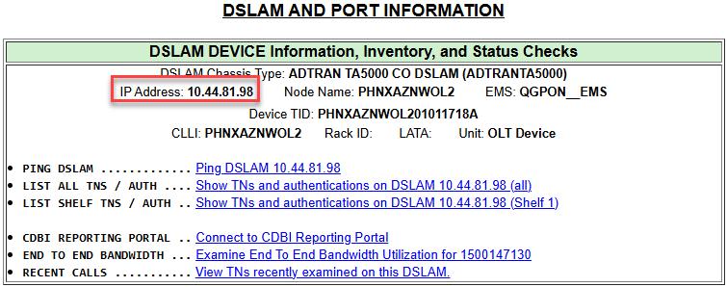
- Open new browser tab and enter IP Address.
- Use Username (CUID) and LDAP Password to log in to Adtran GUI.
- Select Login.


ONT Discovery
Step | Action
Use the customers assigned OLT shelf/slot/port to navigate in the Adtran GUI.
Note: OLT may be found in Poll DSLAM, Optius, or Field Data Tool Kit (FDT).
Following is an example of a RONTA or OLT shelf/slot/port.
- ADTRAN 0001020309 – ADTRAN place holder includes 00 at beginning
- Shelf = 01
- Slot (card) = 02
- PON Port = 03
- ONT= 09
Follow these steps to navigate the assigned ONT in Adtran GUI.
- Select the desired slot (card) from the Modules menu (the module in slot 11 is selected in the example below).
- Select the Provisioning tab.
- Select the ONT tab and ONT sub tabs.
- Set PON to the value that matches the assigned facilities.
Note: it may be necessary to use the navigation at the top or bottom of the page to navigate to the customer’s PON.
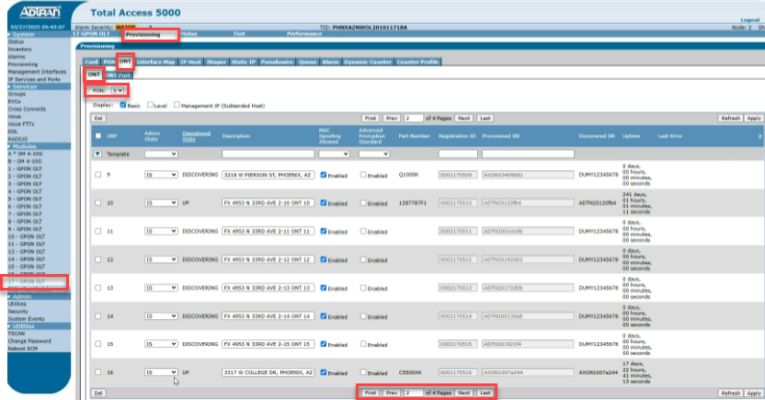
Details for the customers ONT will be displayed.
  - Admin State – indicates whether ONT is In Service (IS) or Out of Service (OOS-UAS).
  - Operational State – indicates UP when the OLT is communicating with the ONT.
Note: if indicates Discovering, the OLT has lost connection with the ONT.
  - Description - indicates the customers address.
  - MAC Spoofing Allowed – should always reflect Enabled with a blue checkmark.
  - Advance Encryption Standard – should always reflect no checkmark.
  - Part Number – reflects model number of the ONT.
Note: field will only be populated when the ONT is connected to the OLT.
  - Registration ID – provides RONTA number.
  - Provisioned SN – provides ONT FSAN Serial Number (SN).
  - Discovered SN – indicates the Serial Number (SN) of the ONT the OLT is communicating with.
Note: the Provisioned SN and Discovered SN should match.
  - Uptime – indicates the duration of communication between the ONT and OLT.
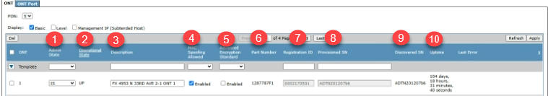

Create New ONT
Step | Action
If the ONT has not been created, it is necessary to create one.
- On the ONT tab in the Create ONT section, from the dropdown list, select the ONT to be created and select Create.
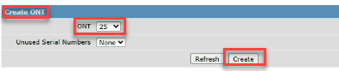
Populate the following fields:
- Description – Customer address
- Registration ID – RONTA from O2
- Provisioned SN – use DUMY12345678 serial number (upper case required)
Note: after creating the ONT, the technician should register the ONT using tech tools to populate the SN.
- Select Apply.
- Change the Admin State to IS.
- Select Apply.
- Select Refresh.
Note: the Provisioned SN field will be greyed out indicating the changes were saved.
- Select the ONT port.
- Select correct PON and ONT from dropdown list.
- Select Ethernet from the dropdown list.
- Select Add button to create an Ethernet port on newly created ONT.
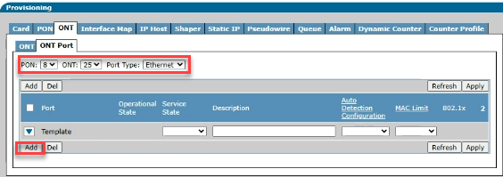
- A window will popup requesting port value.
- Enter the number of Ethernet ports for the ONT model technician is installing.
  - If unknown, enter value of 1.
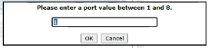
Note: the system will recognize and build additional ports when the technician registers and physically connects the ONT.
Note: additional ports may be added using this feature starting with the correct port number needing to be built.
- Use dropdown to select IS.
- Select Apply.
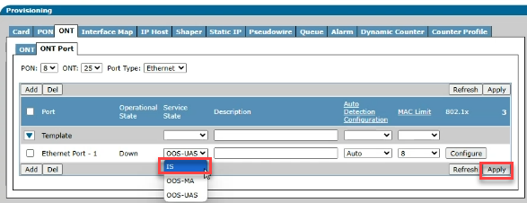
- If working with a technician, ask technician to scan and activate ONT.
- If working Red E, resend to OSG to complete programming.

ONT Activation
Step | Action
The technician should register the ONT using tech tools to populate the SN.
The following should be utilized when the tech tools fail.
- Navigate to customer’s ONT.
- In the Admin State field, use the dropdown to select OOS-UAS.
- Select Apply.
- Select Refresh.
- In the Provisioned SN field, input FSAN Serial Number of the ONT .
Note: if the Description field is blank, input the customer’s address.
- Select Apply.
Note: Only ADTN and AXON serial numbers are allowed limited to AXON C5000XK and Q1000K models.
Note: the Description field can be updated without changing the ONT Admin State.
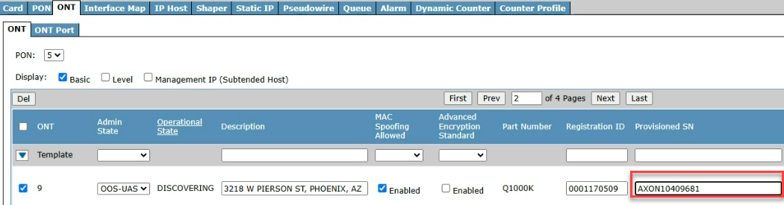
In the Admin State field, use dropdown to select IS (In Service).
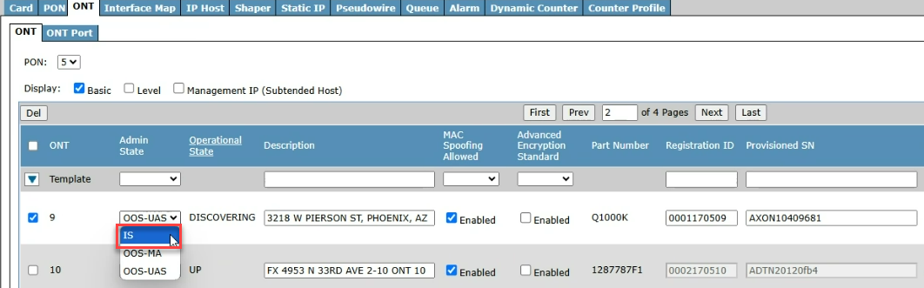
- Select Apply.
- Select Refresh.
Note: the Provisioned SN field will be greyed out indicating the changes were saved.
- This completes the registration of the ONT FSAN serial number.
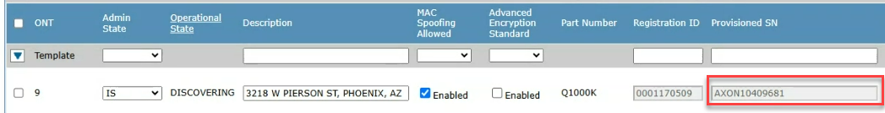

DUMY ONT
This section provides the steps to unlink an ONT in the Adtran GUI and add the DUMY code to allow a field technician to continue the ONT registration process.

This method is useful for DUMY ONT’s. For the example in this guide, equipment ID DNVRCOMAOL1. 00020402.27 on 10.231.172.114 is used an example.

Step | Action
Get the IP Address from POLL DSLAM and log into a GUI session using Edge, Firefox or Chrome.
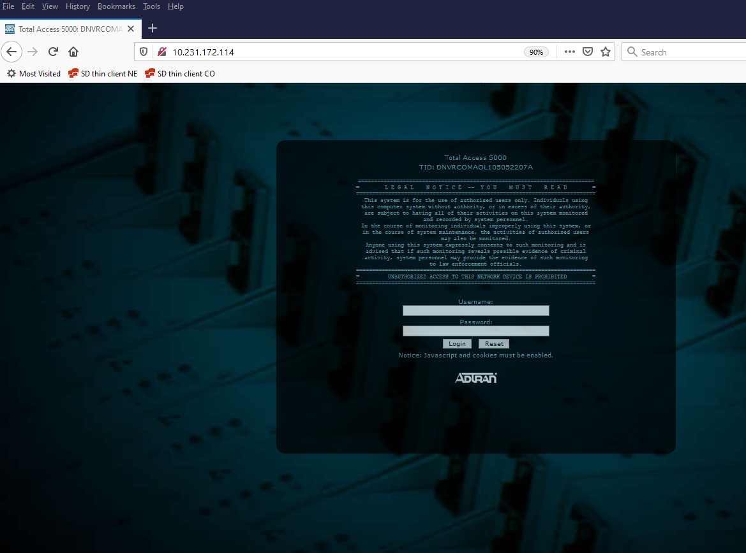
When the GUI for the OLT node displays, select the correct OLT self under the Modules in the box to the left.
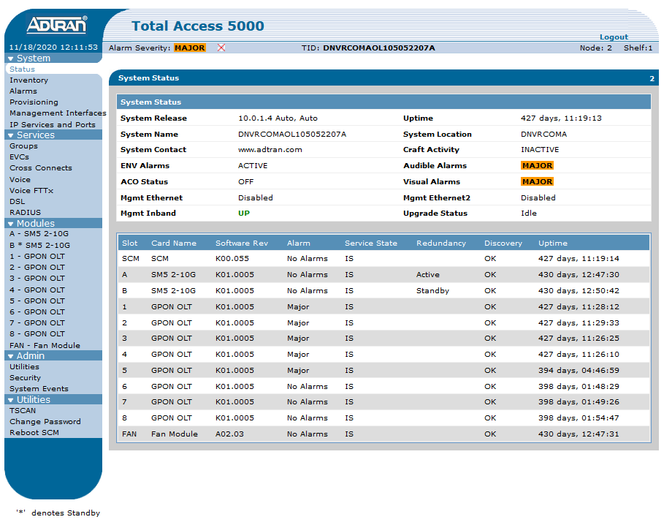
Select tabs: Provisioning, ONT, and ONT.
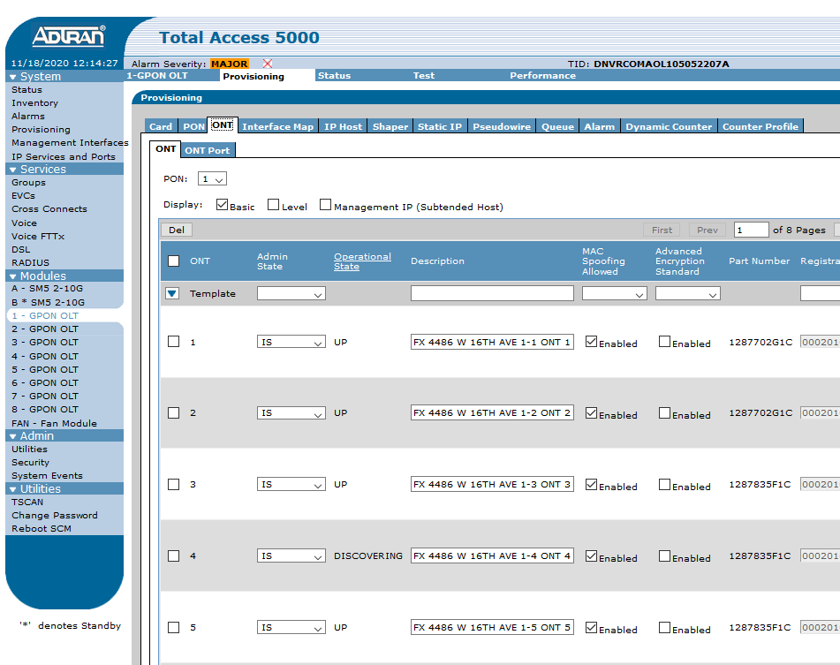
Select the correct PON port from the drop-down box.
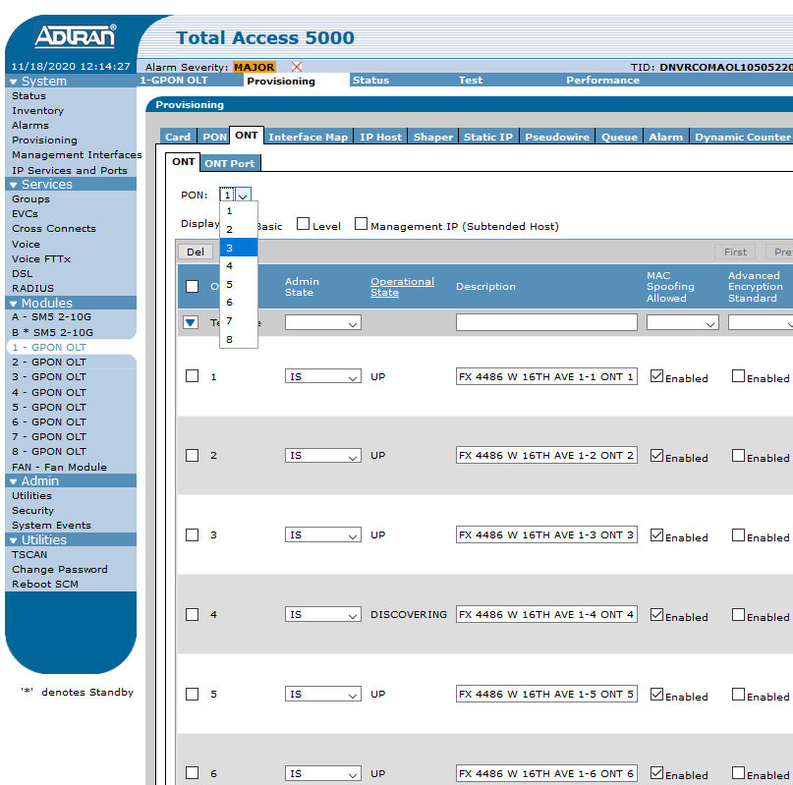
Cycle through the pages until the ONT displays.
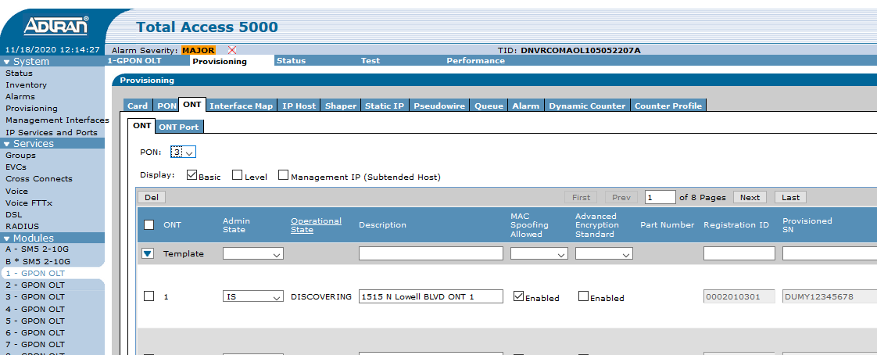
When the correct ONT displays, change the Admin State to OOS-UAS, this will take the Splitter Leg out of service. Then select the Apply button.
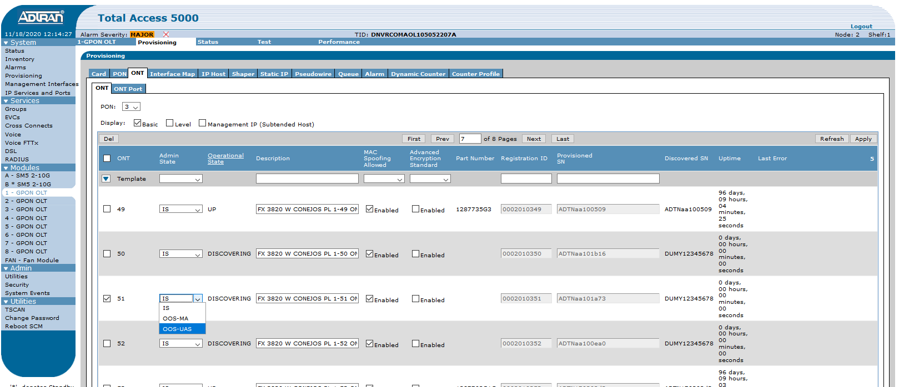
Next select the Refresh button. The Registration ID and Provisioned SN box, which was previously greyed out, becomes available to edit.
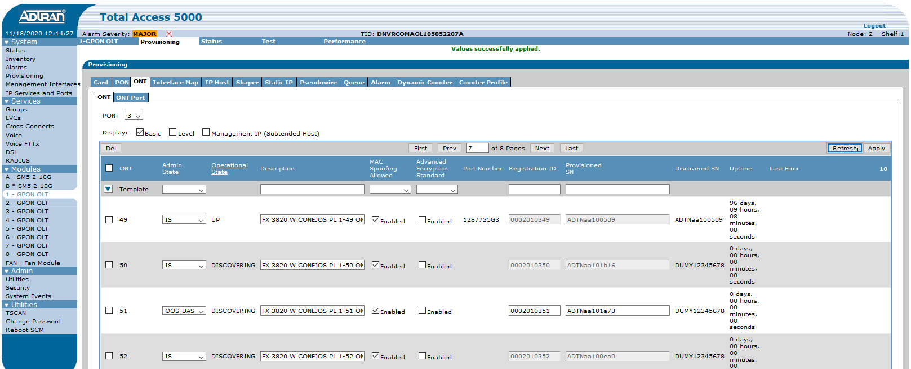
To DUMY out the ONT enter DUMY12345678 in the Provisioned SN field.
After changes are complete, select Apply. Then change the Admin State back to IS, select Apply again.
Next, select Refresh. Review that Provisioned SN field to view changes.
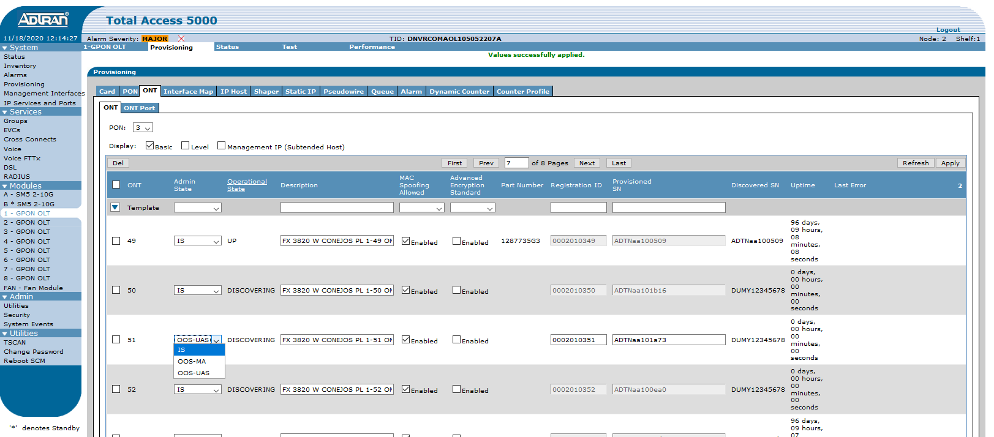
During each of these steps there is message response above that indicates whether the action was successful.
If at any time an error displays, it will be in red and state the reason to why the action could not be completed. Select the error for more detailed explanation.

Note: This process can also be used to manually enter in the serial number of an ONT for the field technician. In the place of DUMY12345678 enter the serial number of the ONT that field technician is wanting to activate.
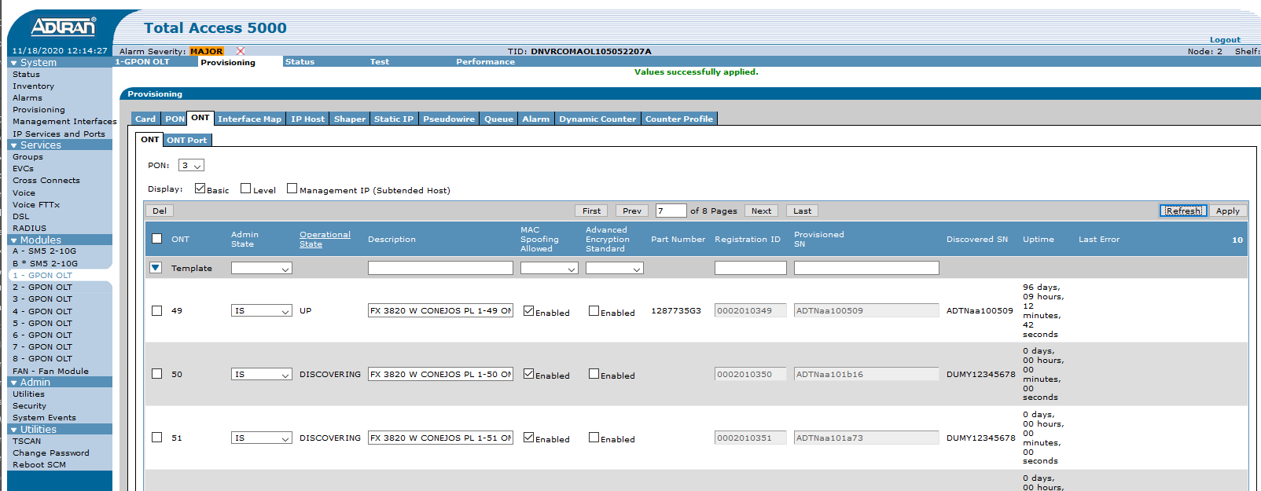

Base ONT provisioning
Step | Action
Now that the ONT has been discovered, agent may provision it. While still on that card’s Provisioning tab and the ONT>ONT sub-tab.
- Set Display to Level.
- Set Battery Backup Monitoring to FALSE.
- Set POTS Service Mode to GR 303.
- Select the Apply button at the far right of the page.
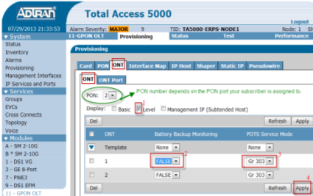
Note: agent may select multiple displays as shown below (Basic and Level). As each check box is checked, information expands to the right of the screen. However, there is no need to select the last check box <Management IP (Subtended Host)> since none of those options need to be set.
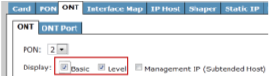

Provision the ONT, Ethernet Port
Step | Action
When the Ethernet port is Out of Service User Assigned (OOS-UAS), while still on that card’s Provisioning tab and the ONT sub-tab:
Note: the Ethernet port in Poll DSLAM will display as disabled in the Provisioned State field.
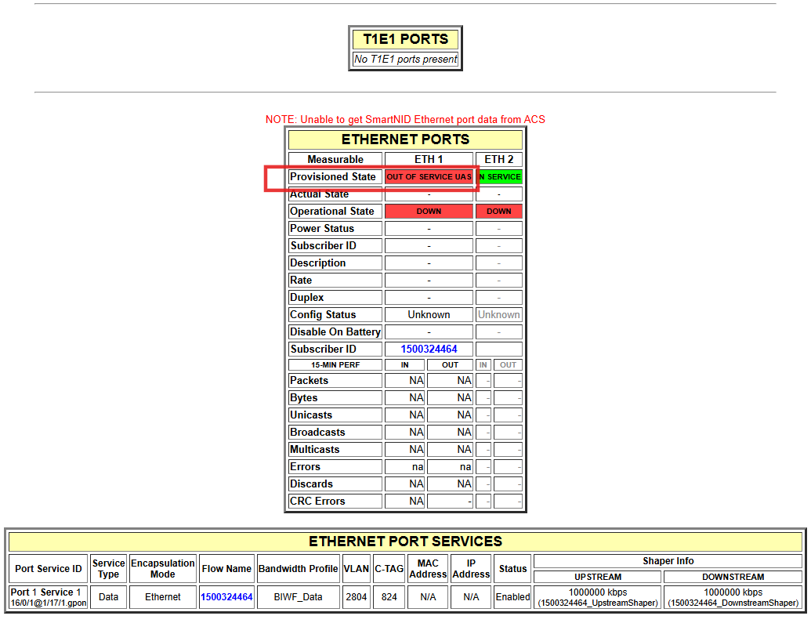
- Change to the ONT Port sub-tab.
- Set Port Type to Ethernet (which is the default value).
- Set Service State to IS.
- Leave all other options at default values and select the Apply button.
Note: it is necessary to in-service the port using the Apply button. The Add button will prompt to add another port which is not valid for Lumen hardware (since all possible ports should exist and already be displayed).
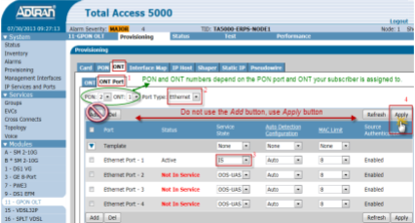

Create Interface Map
Step | Action
Note: Status of evc-maps (cross connects) will be UNI not available for use until the ONT’s ethernet port it’s built on is configured to be set enabled. Then evc-map status will change to a good running state.
- Select the desired card from the Modules menu (the module in slot 11 is selected in the example below)
- Select the Provisioning tab.
- Select the Interface Map tab.
- Enter the subscriber’s DTN for the Map Name.
- Select the Create button.
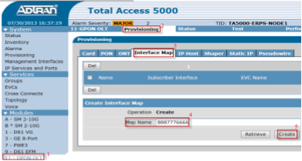
The Interface Map just created will open in an edit mode and will initially have a Subscriber Interface description of Not Specified.
- Enter BIWF_Data for the Description.
- Set the Service State to Active.
- Set the PON, ONT, and ONT Port numbers to the values from O2 subscriber info.
- Set Upstream channel (matches the ONT port#).
- Set the EVC Name to the SVLAN value from O2 subscriber info.
- Set S-Tag Priority to Marked.
- Set the S-Tag Priority to 0.
- Set the C-Tag to the CVLAN value from O2 subscriber info.
- Set C-Tag Priority to Marked.
- Set the C-Tag Priority to 0.
- Set DHCP Processing to Authenticate.
- Set DHCPv6 Processing to Same as DHCPv4.
- Set PPPoE Processing to Block.
- Select the Advanced button to expand more options .
- Enter default for Circuit ID Format field.
- Set Remote ID to Enabled.
- Enter $map$ for the Remote ID Format field.
- Set Option 82 Insert to Enabled.
- Set CE-VLAN to 201.
- Only on 4port and 8port OLT cards, select the appropriate QoS Map Profile.
  - Ignore this for 2port cards (2port cards do not support per-port shaping and don’t require use of QoS Map Profiles).
  - The correct value depends on which ONT Ethernet port the subscriber is connected to:
ONT Ethernet Port Number | QoS Map Profile Name
1 | DN-MAP1
2 | DN-MAP2
3 | DN-MAP3
4 | DN-MAP4
Note: refer to the work ticket in Optius. The Add-Data-XC Command line will display the interface map attributes.
Select the Apply button at the bottom of the screen to save.
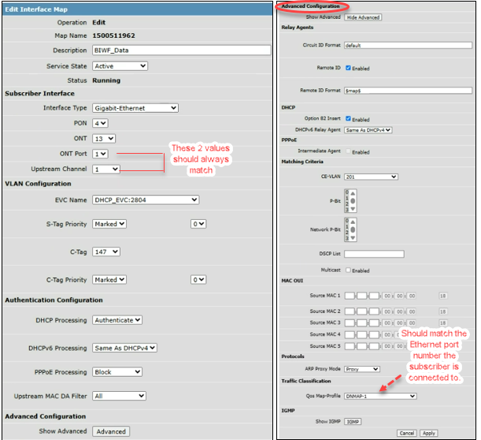
As stated at beginning of this section, it is necessary to enable the ONT’s Ethernet port for evc-map status to change to good running state. (Resolves UNI not available for use error.)

Note: if UNI not available error persists it could be an indicator of incorrect interface map settings. Verify the QoS Map profile, and CVLANs are correct per Optius. Reach out to a lead for assistance if unable to clear error.

Subscriber Interface
Step | Action
The subscriber interface follows this format.
Example: GE 10/0/2@1/17/4
- GE represent the Gibabit Ethernet port.
- The sequence of numbers following the GE represent the ONT.
  - Example: 10 = ONT; 0 = place holder; 2 = Ethernet port
- The numbers following the @ symbol represent the OLT shelf/slot/port (1/17/4).
Tip: when searching for a specific subscriber interface, one recommendation is to review the set of numbers after the GE.
- Once the ONT is found, verify the correct shelf/slot/port.

Create Shapers
Step | Action
- Each shaper must be configured with a name, which is unique.
  - The system responds with an error message if attempting to create a shaper with the same name already in use, or if no name is specified.
  - The naming schema for shapers is the subscriber’s DTN followed by underscore and DownstreamShaper or UpstreamShaper.
Note: Shapers must be in this format DownstreamShaper or UpstreamShaper to avoid system fallout.
- Ex. 8886667777_DownstreamShaper and 8886667777_UpstreamShaper.
- If making a speed change, agent may locate a given subscriber’s existing shapers and edit the speeds on those shapers by changing the rate values and then selecting the Apply button.

Creating Downstream Shaper

Step | Action
- Select the desired card from the Modules menu (the module in slot 11 is selected in the example below).
- Select the Provisioning tab.
- Select the Shaper tab.
- Enter the subscriber’s DTN_DownstreamShaper for the Name.
- Select the Create button.
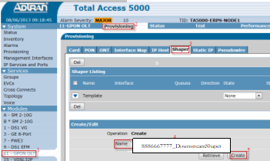
After the shaper opens in Create/Edit mode.
- Set State to Active.
- Set Interface to Remote Device.
- In the PON field, use dropdown to select the assigned PON.
- In the ONT field, use dropdown to select the assigned ONT.
- In the Shaper Direction field, use dropdown to select Downstream.
- In the Queue field, select the appropriate queue.
- Set the Queue to the value that aligns with the ONT Ethernet port number.
ONT Ethernet Port Number | Queue Number
1 | 0
2 | 1
3 | 2
4 | 3
- In the Channel field, select the appropriate channel.
Note: should match the ONT Ethernet port number.
- Set the Rate to the value corresponding to subscriber’s ordered speed (the downstream rate).
Purchase Speed | Rate (downstream)
200M | 220000
500M | 550000
940M | 1000000
2G | 2200000
- Leave all other values at default and select the Create button.
Note: The Shaper Name format is now DTN_DownstreamShaper EX. 8886667777_ DownstreamShaper.
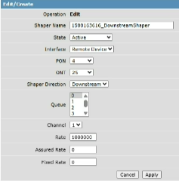

Creating Upstream Shaper

Step | Action
- Select the desired card from the Modules menu (the module in slot 11 is selected in the example below).
- Select the Provisioning tab.
- Select the Shaper tab.
- Enter the subscriber’s DTN_UpstreamShaper for the Name.
- Select the Create button.

After the shaper opens in Create/Edit mode.
- Set State to Active.
- Set Interface to GPON.
- In the PON field, use dropdown to select the assigned PON.
- In the ONT field, use dropdown to select the assigned ONT.
- In the Shaper Direction field, use dropdown to select Upstream.
- In the Channel field, select the appropriate channel.
Note: should match the ONT Ethernet port number.
- Set the Rate to the value corresponding to subscriber’s ordered speed (the downstream rate).
Purchase Speed | Rate (upstream)
200M | 220000
500M | 550000
940M | 1000000
1G | 1100000
- Leave all other values at default and select the Create button.
Note: The Shaper Name format is now DTN_UpstreamShaper EX. 8886667777_ UpstreamShaper.
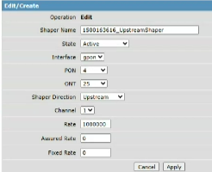

Identify Interface Map

Sometimes the Interface Map Name is unknown (the Name field), so it would need to be found by the Subscriber Interface.

In order to find the Subscriber Interface, it will be important to know how to understand the Subscriber Interface format.

Looking at the example image below, the Subscriber Interface is GE 1/0/1/@1/17/4
The way to read this would be the information after the @ symbol is the OLT placement (shelf/slot/port)
The GE # represents the ONT number (aka Leg), followed by a Zero (default, represents nothing), followed by the Ethernet port # (GIGE port)

To find the correct Subscriber interface, the Agent may have to go page by page until it can be located.

Once it’s identified, it can be verified if it’s correct, or if it needs to be deleted using the Del button.

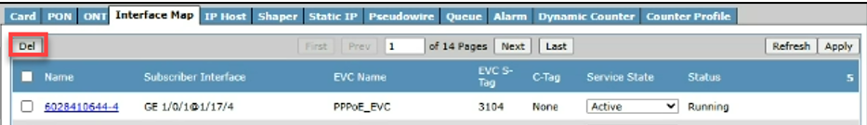

Deleting Interface Map or Shaper
Step | Action
- Select the desired card from the Modules.
- Select the Provisioning tab.
- Select the Interface Map tab or Shaper tab.
- Use the navigation buttons to scroll through pages until the desired Interface Map or Shaper is displayed.
- Place a check in the box(s) to the left of the Interface Map or Shaper(s) to be deleted.
- Select the Del button to delete the mapping(s).
Note: both Del buttons provide the same function.
Important: confirm subscriber interface prior to deleting.
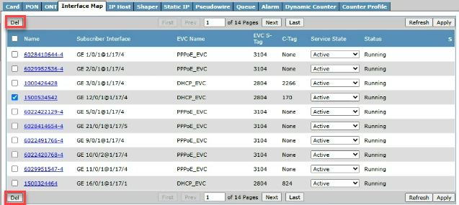

Firmware
To identify the SmartNID Firmware go to the ONT screen and verify the ONT Active Software Version field for the corresponding ONT.

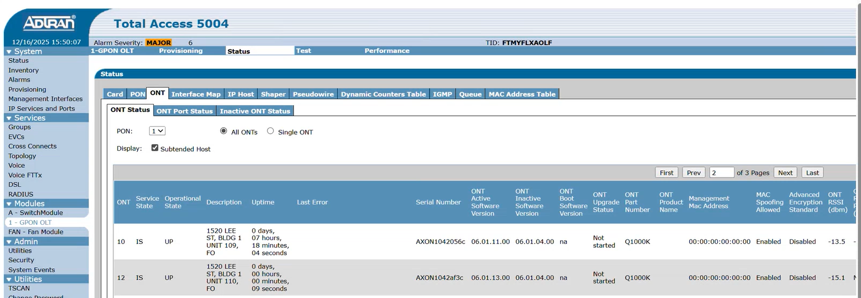

Troubleshooting

PON Operational Status/Testing
Step | Action
On a TA5000 it is normal for a GPON port to be in Testing status until the first ONT connects to that port.
- To review the PON statuses, navigate to the Status tab.
- Select the PON tab.
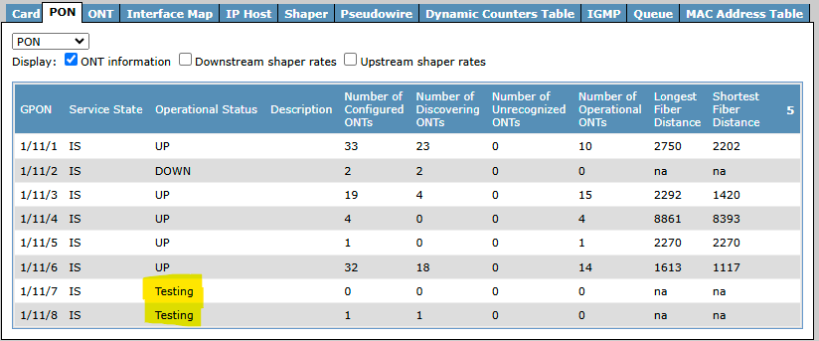
Agent can manually toggle the port out of Testing status by disabling and enabling (setting port to OOS-UAS then back to IS).
- Navigate to the Provisioning tab.
- Select the PON tab.
- Change the Service State from IS to OOS-UAS and select Apply and Refresh.
Note: the technician should lose light. If light is not lost, the technician could be on the wrong facilities or a splicing failure.
- Change the Service State from OOS-UAS to IS and select Apply and Refresh.
- It will then go to a Down status unless an ONT is connected and provisioned correctly.
Important: This action is only allowed if the PON is showing Down or Up, the status should never be changed.
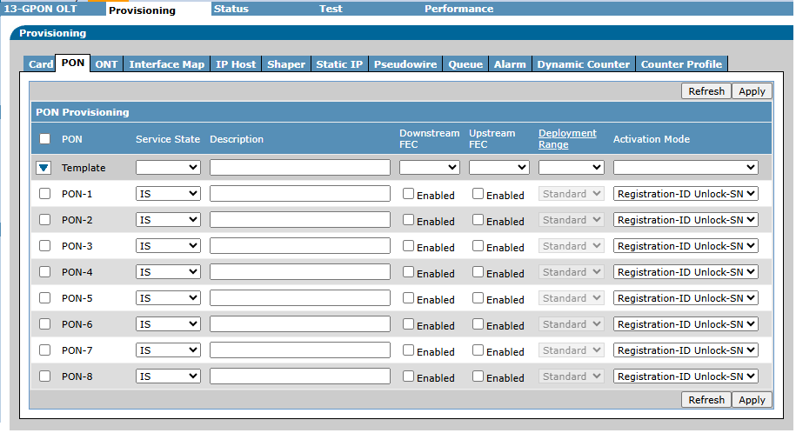

Searching Unrecognized ONT’s
Step | Action
Go to Status, then PON.
Search for value that is greater than zero in the Number of Unrecognized ONTs column.
Example:
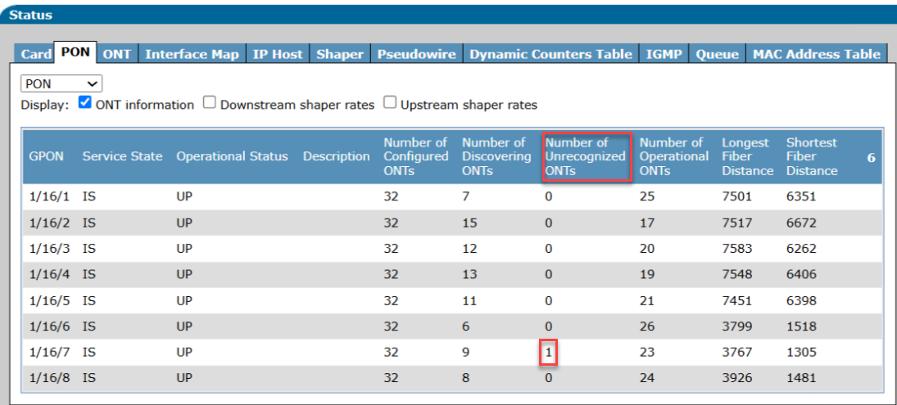
- On Status tab, select ONT tab and Inactive ONT Status tab.
- Select the PON Port from the drop down.
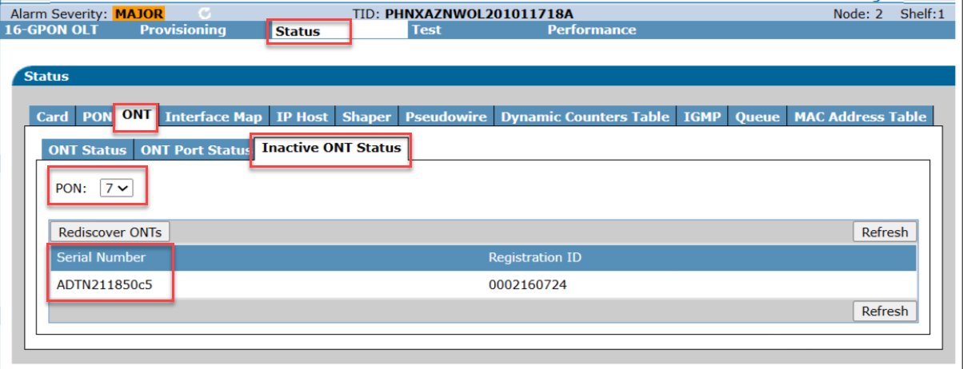
If the serial number matches the ONT/SmartNID serial number of the field technician’s ONT/SmartNID, take note of the PON Port and direct field technician to verify the Splitter Leg is connected correctly at the FDH.
Tip: if serial number displays with all zero’s or is blank, request the technician disconnect the ONT from power. Serial number should disappear from the list upon refresh.
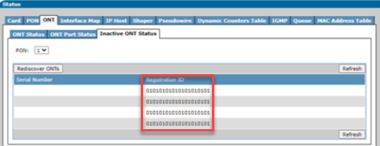

Using FDT to Verify Assigned Splitters at FDH
Step | Action
 | Navigate to Field Data Toolkit (FDT).
 | Navigate to the Fiber Distribution Hub (FDH) in the FDT.
Select Enable Splitter View.
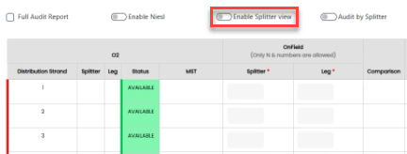
Verify the OLT CLLI/Device name and shelf, slot, port.
- Using this information, perform steps for searching unrecognized ONT/SmartNID on all Splitters that the technician could possibly be connected to.
- The agent may need to change the module within the Adtran GUI to search the correct PON port for additional unrecognized ONT/SmartNID.
Example: splitter 1 is connected to PTLDOR11OL2 and splitter 4 is connect to PTLDOR11OL4.
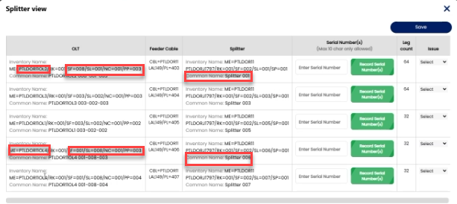
TIP: to find the IP address for other OLT’s, perform a search in ODiN using the Distinguished Name. Example: ME=PHNXAZNWOL4.
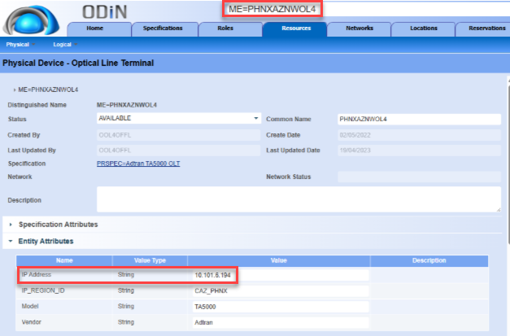

Conflict with EVC Map Error
Step | Action
 | Agents may see this error when attempting to program an Interface Map.
Research DTN provided in error message to determine if there is a VLAN assignment conflict.
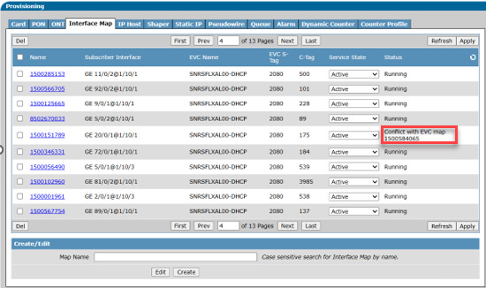
Input the DTN in O2 to view the assigned facilities.
If | Then
The DTN is assigned to different VLAN. | Correct programming.
The DTN is assigned to the same VLAN. | Leave current customer programmed and reassign new customer a new path.

Identifying if ONT Serial Number is Connected to Wrong Splitter
This section outlines how to identify if the field technician mis-wired the connection at the FDH to the wrong Splitter Leg.

Step | Action
Check to see if there’s a mis-wired Splitter Leg at the FDH. In the Adtran GUI navigate to the OLT in question.
Click on Status, ONT and Inactive ONT Status tabs.
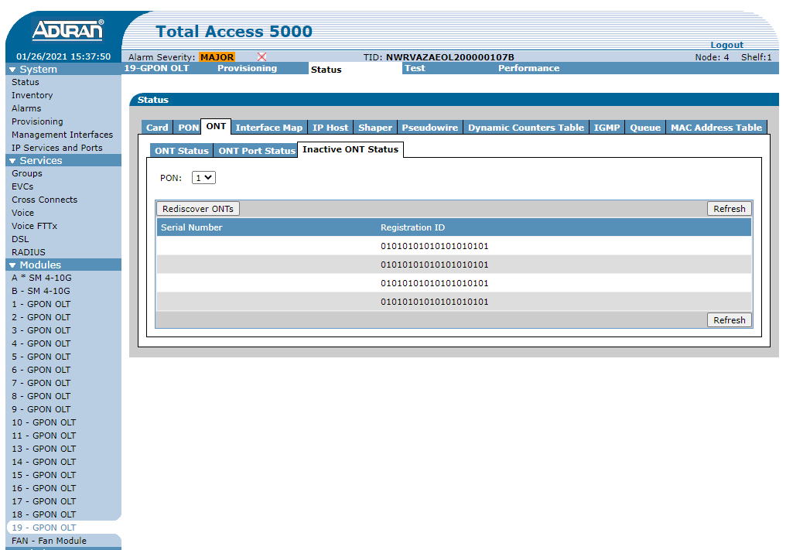
Select the PON Port from the drop down. Be sure to check all the different PON Ports.

This is an example of an ONT serial number that showing without a RONTA.
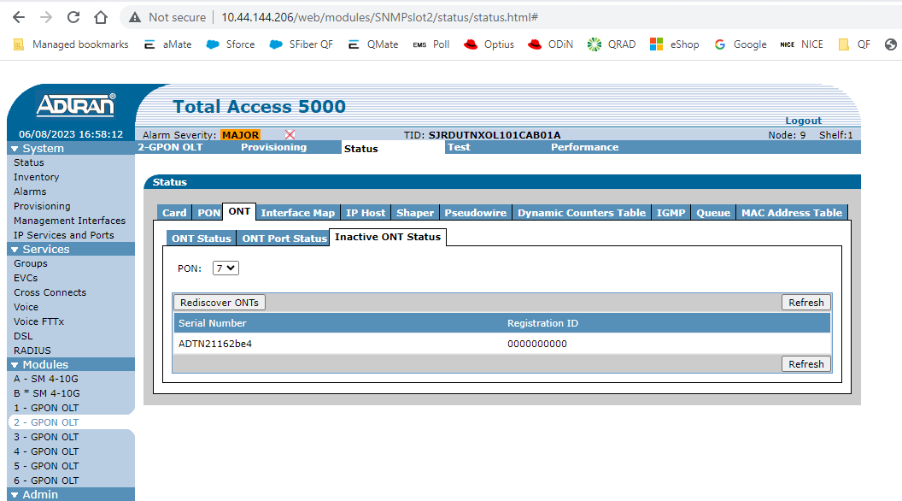
This is an example of an ONT serial number that showing with a RONTA.

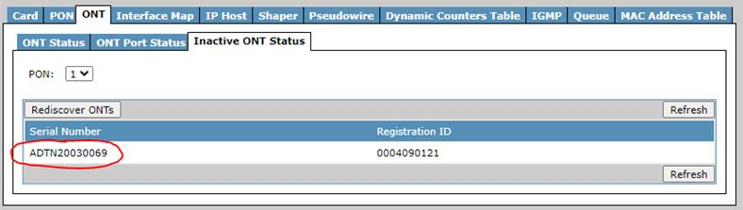
 | If the ONT serial number matches the ONT serials number of the field technician’s ONT, take note of the PON Port and direct field technician to verify the Splitter Leg is connected correctly at the FDH.

Document Management

Document Management
AUTHORS
Author | SME |  | Name |  |  |  | Telephone Number | E-mail Address
X |  |  | Debra Rudrud |  |  |  | 214-617-2123 | Debra.rudrud@forgedfiber37.com
 | X |  | Kyle Field |  |  |  | 208-646-3594 | Kyle.Field@forgedfiber37.com
 | X |  | Angie Shoecraft |  |  |  | 206-245-2894 | Angela.M.Shoecraft@forgedfiber37.com
REVISIONS
Date |  | Issue |  | Revised By |  | Comments
04/01/25 |  | 1 |  | Joela Flaxa |  | Initial version.
04/09/25 |  | 2 |  | Joela Flaxa |  | Added DUMY ONT information.
05/07/25 |  | 3 |  | Joela Flaxa |  | Added section for creating a new ONT.
05/22/25 |  | 4 |  | Joela Flaxa |  | Correct shaper downstream rate and added clarification throughout document.
05/28/25 |  | 5 |  | Joela Flaxa |  | Added troubleshooting section to document.
06/06/25 |  | 6 |  | Joela Flaxa |  | Added Conflict with EVC Map Error message to troubleshooting section.
02/06/26 |  | 7 |  | Debra Rudrud |  | Changed document Author from Joela Flaxa to Debra Rudrud.  Updated the DUMY ONT section to include precursory steps from the separate Adtran – DUMY ONT (QF Tech Assist) document, as that document will be archived.  Added the Identifying if ONT Serial Number is Connected to Wrong Splitter section and archived the separate document Adtran – Identifying if ONT Serial Number is Connected to Wrong Splitter (QF Tech Assist and QF Structure Load).  Removed the link to the Poll Dslam document, per Poll Dslam did not come to FF37.
02/24/26 |  | 8 |  | Debra Rudrud |  | Added the Firmware section.  Added the Identify Interface Map section.
APPROVAL
Name |  |  |  |  | Title |  |  |  | Date Approved
Liz Bordano |  |  |  |  | Manager – Mass Markets Ops Excellence |  |  |  | 04/01/2025

